**GOVERNMENT ARTS COLLEGE (AUTONOMUS)**

**COIMBATORE-641018**

DEPARTMENT OF STATISTICS

NAAN MUDHALVAN COURSE: DATA ANALYTICS WITH TABLEAU

CLASS: lll YEAR B.Sc. STATISTICS – SEMESTER:5

PROJECT REPORT

(PROJECT DOCUMENTATION)

NM TEAM NUMBER : 1

NM ID : NM2023TMID25004

NM PROJECT TITLE : SUBSCRIBERS GALORE : EXPLORING WORLD`S

TOP YOUTUBE CHANNELS

MENTOR : Dr.G.K.BALACHANDRAN.M.sc.,M.phil.,

ASSISTANT PROFESSOR

SUBMITTED BY

1. JERIKSON.G - 21BSTO34 [B944FB45B4EC92EBA1345696BC609BFA]

2. ABINAYA.V - 21BST001 [6E5B2E06F757E1488E0401DA7841BB3B]

3. ADHITHYAN.S - 21BST026 [B917E8ECE65D1CF8CF744BA6B1898D73]

4. DHARINI.M - 21BST006 [FBA77E0E9A8BA35AA204AD812D573E52]

SUBMITTED TO

*Smart bridge educational services Pvt.Ltd.*

***SUBSCRIBERS GALORE : EXPLORING WORLD'S TOP YOUTUBE CHANNELS***

1. *Introduction*

“Subscribers Galore: Exploring the World’s Top YouTube Channels” is a YouTube series or content theme that delves into the most popular and influential YouTube channels across various categories. It provides in-depth analysis, reviews, and insights into these channels, discussing their content, creators, and the factors contributing to their success. The series aims to help viewers discover new content and creators, understand the dynamics of YouTube’s platform, and gain inspiration from the top channels. It often features interviews with the creators and explores the impact and trends within the YouTube community.

Subscribers Galore empowers individuals and businesses to achieve the following:

* Subscriber Growth: Learn proven strategies to attract and retain subscribers, resulting in a larger and more loyal customer base.
* Monetization: Discover how to generate revenue from your subscribers, whether through subscription fees, advertising, or other monetization methods.
* Audience Engagement: Understand how to keep your subscribers engaged and satisfied, leading to increased brand loyalty and word-of-mouth referrals.

Subscribers Galore offers a versatile platform with a range of applications for content creators, business owners, marketing professionals, entrepreneurs, education and networking, and etc…

1. Problem definition & design thinking :-

Subscriber’s Galore aims to analyze, explore and understand the world’s Top YouTube channels based on their subscriber count. This analysis provides valuable insights and information about there channels, such as their content genres, growth trends, engagement metrics in order to help content creators, marketers and enthusiasts to gain a deeper understanding of the YouTube landscape. The main objective of Subscriber’s Galore is to become a valuable resource for any one interested in understanding the YouTube ecosystem and provide recommendations and insights for content creators and marketers to enhance their strategies and to create a user-friendly platform for easy access to the data and to promote marketing and research

* Empathy mapping

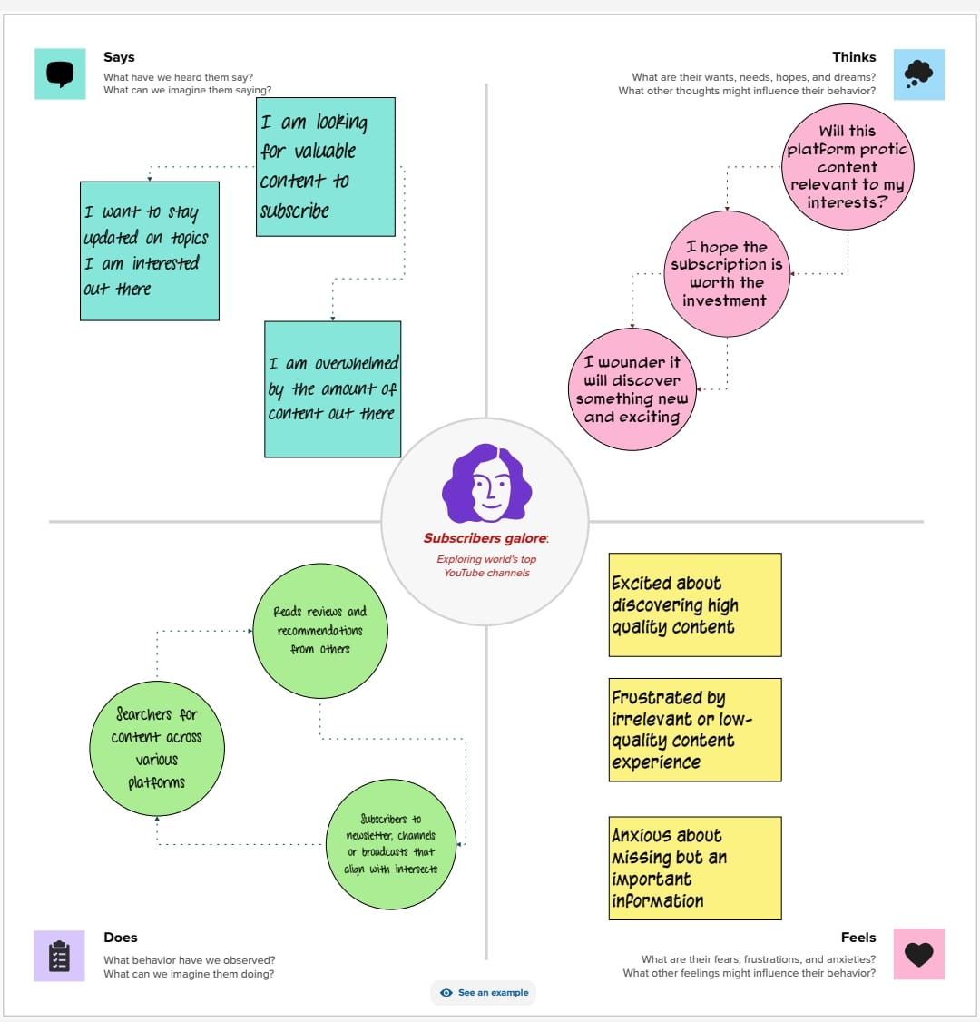

* Brainstorming map

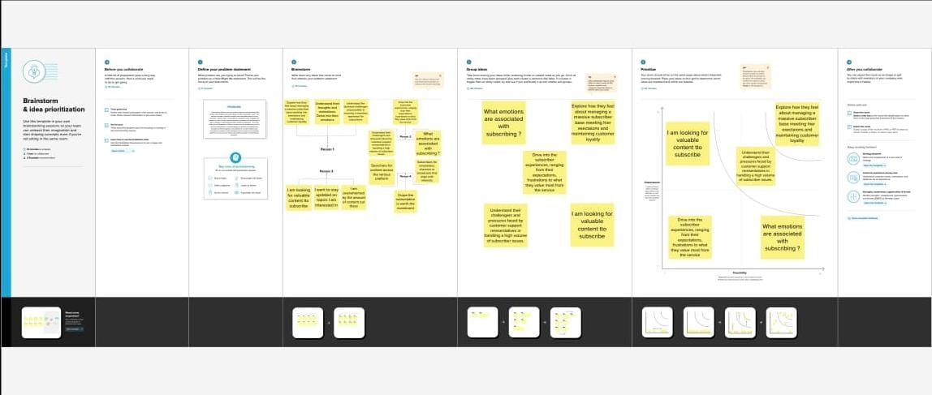

1. Result :-

Result for dashboard

Visualizations

List of branded channels dashboard

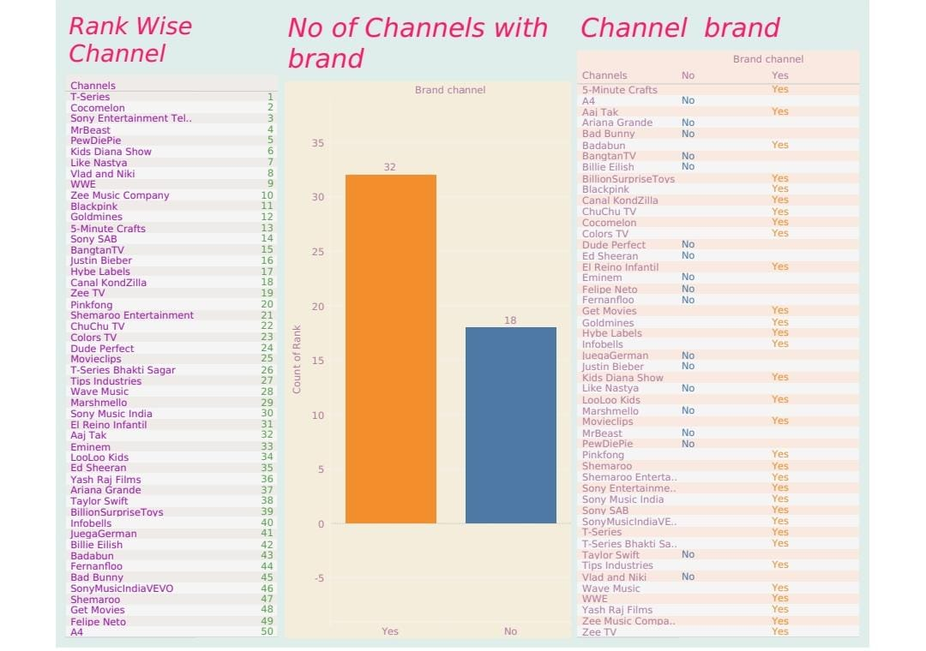

Charts represent the number of

Subscribers for each channels dashboard

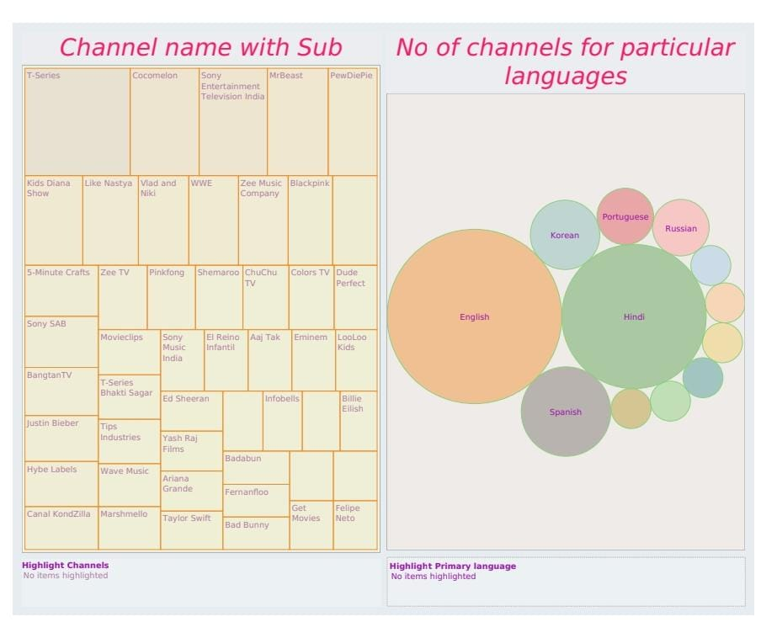

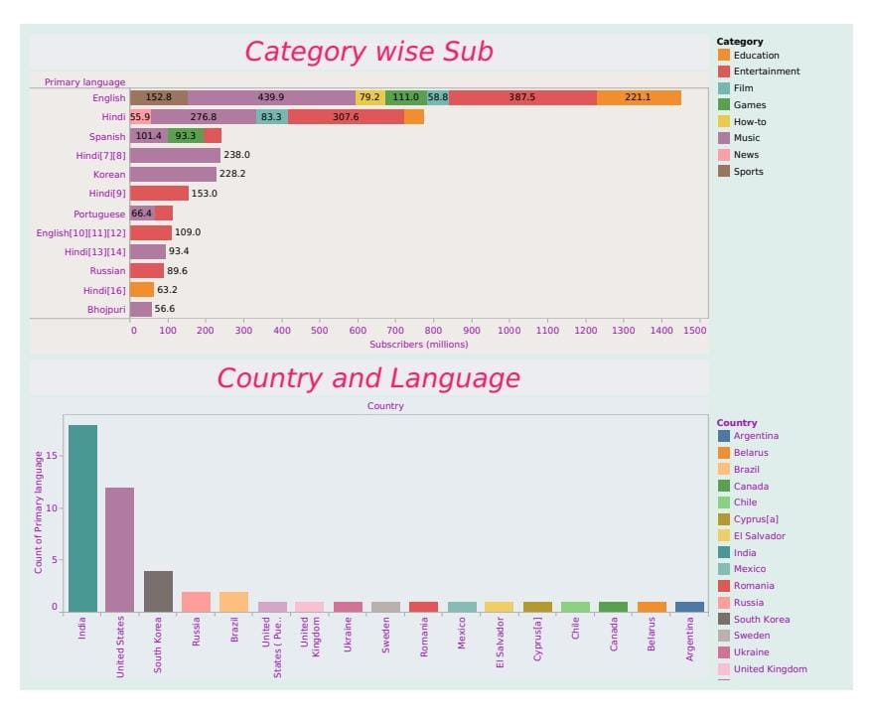

Count of subscribers based on their

Category and languages dashboard

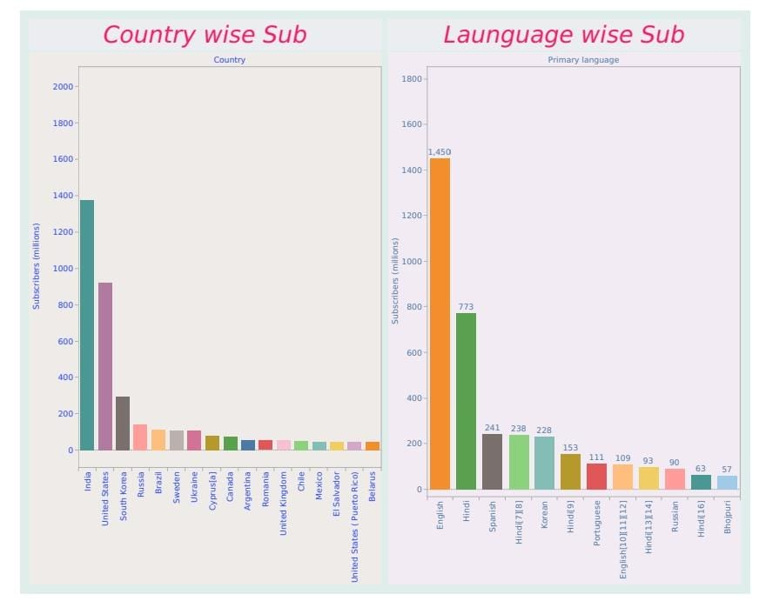

Story for subscribers galore :-

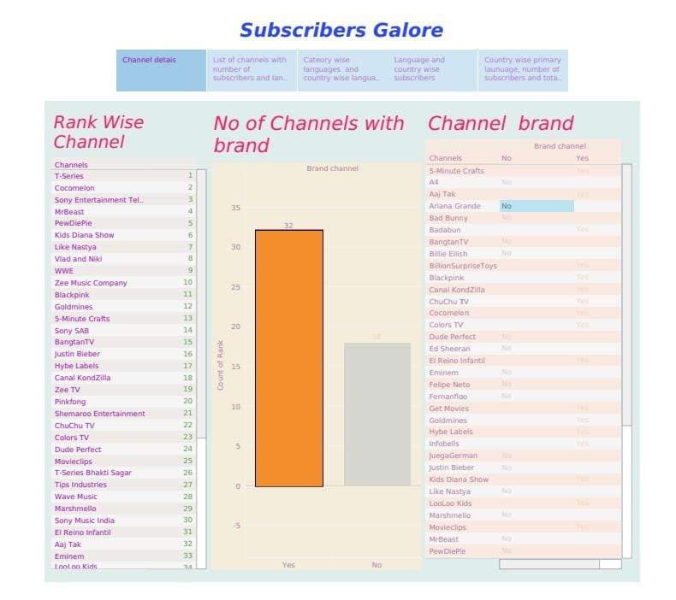

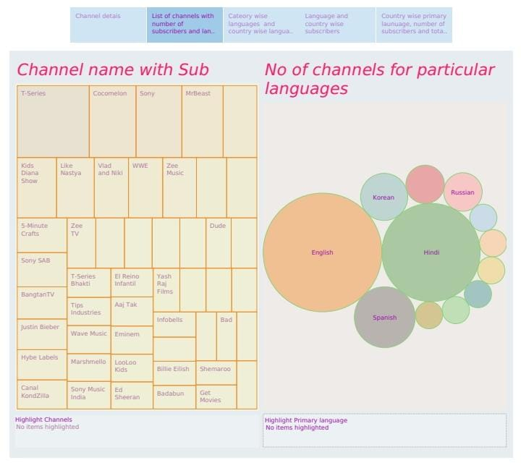

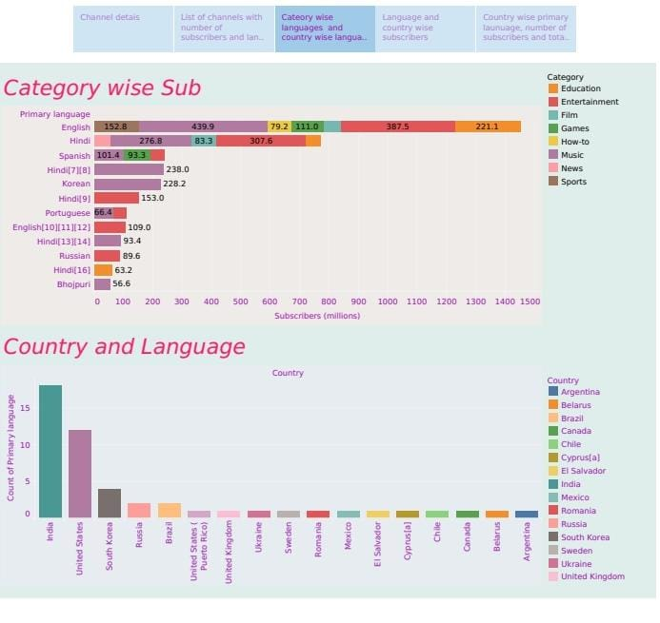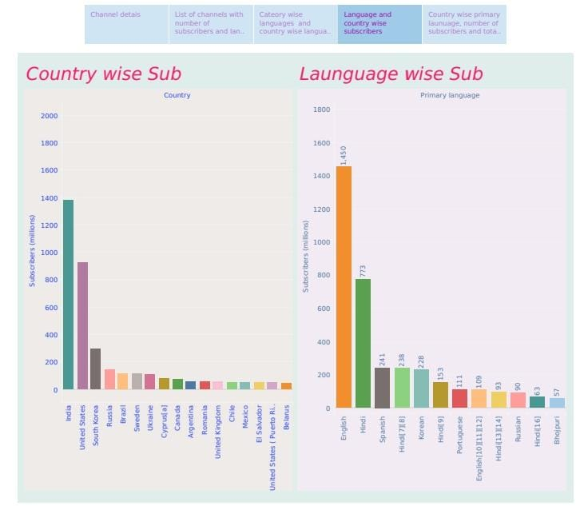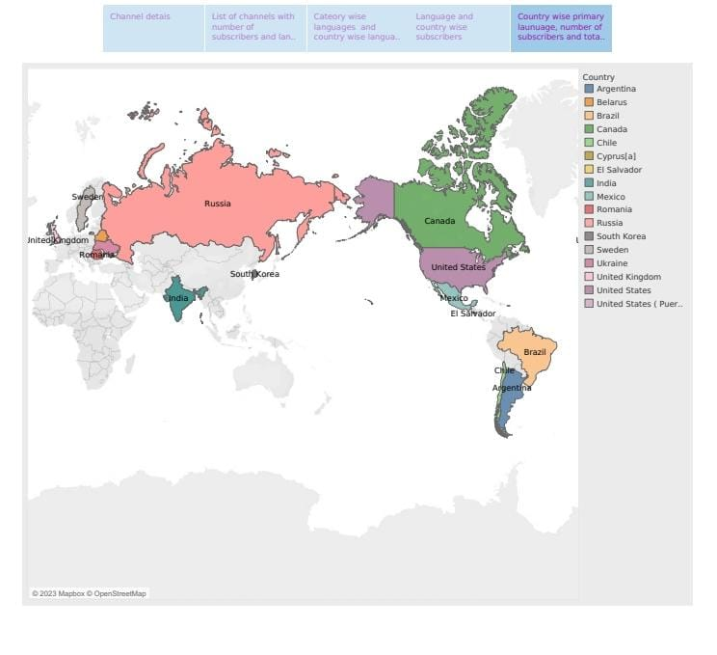

1. Advantages & Disadvantages:-

Advantages:-

* Cost Savings: Subscribers often enjoy discounted prices or bundled packages, saving money compared to one-time purchases.
* Exclusive Content: Many subscriptions provide access to exclusive content, such as streaming platforms with original shows and movies.
* Convenience: Subscriptions can simplify your life by automating services like grocery deliveries or streaming music.
* Early Access: Subscribers may get early access to products, sales, or events, giving them a competitive advantage.
* Personalization: Some subscriptions use data to tailor experiences, like personalized playlists or product recommendations.

Disadvantages :-

* Cost Accumulation: Multiple subscriptions can add up quickly, leading to higher monthly expenses.
* Subscription Fatigue: Managing numerous subscriptions can be overwhelming and lead to subscription fatigue, causing stress and decision fatigue.
* Unused Services: Subscribing to too many services may result in underutilized or forgotten subscriptions, wasting money.
* Contractual Commitment: Some subscriptions require long-term contracts or cancellation fees, making it difficult to switch or terminate services.
* Privacy Concerns: Some subscription services collect personal data, raising privacy and security concerns.

1. Applications :-

Managing multiple subscriptions efficiently can be challenging, but there are several applications that can help you stay organized and make the most of your subscriptions. Here are some applications for handling subscribers galore:

* Truebill : Truebill helps you track and manage your subscriptions, providing insights into your spending and assisting with cancellation.
* Trim: Trim analyzes your spending and identifies opportunities to save on subscriptions. It can also assist in canceling unwanted services.
* SubscriptMe : SubscriptMe is a subscription tracker that helps you monitor all your recurring payments in one place and set up alerts for upcoming charges.
* Bobby: Bobby is an iOS app that helps you keep track of subscriptions and recurring expenses, allowing you to budgetmore effectively.
* Clarity Money: Clarity Money offers subscription tracking, expense analysis, and budgeting tools to help you gain control over your finances.

1. Conclusion :-

The world of subscriptions, with its myriad services and offerings, presents both advantages and disadvantages. Subscribing to various services can provide cost savings, exclusive content, convenience, and access to a range of products and experiences. However, it's important to manage subscriptions wisely to avoid overspending, subscription fatigue, and privacy concerns. Utilizing subscription management apps can help individuals organize, track, and optimize their subscriptions, ultimately leading to a more efficient and cost-effective subscription experience. Balancing the benefits and drawbacks of subscribers galore requires thoughtful consideration of one's needs and priorities to make informed subscription choices.

1. FUTURE SCOPE :-

The future scope for subscribers galore is likely to continue evolving and expanding in various ways:

* Personalization: Subscriptions will become even more tailored to individual preferences. AI and data analytics will play a significant role in curating content and services for subscribers.
* Bundling and Integration: Companies may offer comprehensive bundles that combine multiple services into one subscription, creating convenience and cost savings for consumers.

*Thank you!!*